**BUCKTAIL COUNCIL**

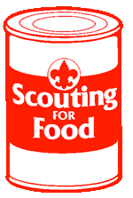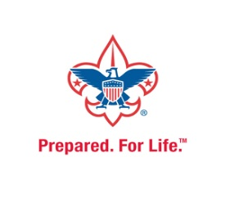

**BOY SCOUTS OF AMERICA**

**GOOD TURN FOR AMERICA**

**SCOUTING FOR FOOD DRIVE**

**The Bucktail Council, Boy Scouts of America has teamed up with local Scout units and businesses to help collect food for local food pantries. Scouts are out and about in the Community conducting this National Good Turn for America service project in hopes of making the future a little bit brighter for those in need.**

**Please help local families and the food bank by reaching into your cupboard and filling at least one grocery bag with nonperishable food items for Scouts from Unit(s) to pick up from your home on Date.**

**Food Pick-Up**

**Saturday, Your Date, starting at time**

**If you would like to make a food donation, please place it in a grocery bag or box and leave it on the front porch so that the Scouts can pick it up.**

**Thank you!**

**Should you have questions please feel free to call contact info**

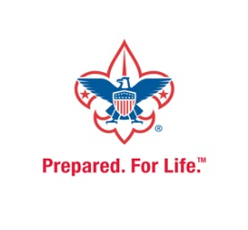

**BUCKTAIL COUNCIL**

**BOY SCOUTS OF AMERICA**

**GOOD TURN FOR AMERICA**

**SCOUTING FOR FOOD DRIVE**

**The Bucktail Council, Boy Scouts of America has teamed up with local Scout units and businesses to help collect food for local food pantries. Scouts are out and about in the Community conducting this National Good Turn for America service project in hopes of making the future a little bit brighter for those in need.**

**Please help local families and the food bank by reaching into your cupboard and filling at least one grocery bag with nonperishable food items for Scouts from Unit(s) to pick up from your home on Date.**

**Food Pick-Up**

**Saturday, Your Date, starting at time**

**If you would like to make a food donation, please place it in a grocery bag or box and leave it on the front porch so that the Scouts can pick it up.**

**Thank you!**

**Should you have questions please feel free to call contact info**